

Action Recognition Algorithm Research with Multifunction Glow-Stick

M.Sc. (Software Design and Development)
National University Of Ireland, Galway
Discipline of Information Technology
College of Engineering & Informatics

Student: Jie Sun
Student Number: 16230972
Academic Supervisor: Dr. Frank Glavin

Table of Contents

Action Recognition Algorithm Research with Multifunction Glow-Stick 1
Table of contents 5
Declaration 5
List of Figures 5
List of Tables 7
Glossary of Abbreviations 8
Acknowledgements 9
Abstract 10
1 Introduction 11
1.1 Background Information 11
2 Accelerometer with steps algorithm 12
2.1 The introduction and working principle of an accelerometer 12
2.1.1 What is an accelerometer 12
2.1.2 Working principle of an accelerometer 12
2.1.3 How an accelerometer works in mobile phone. 13
2.2 The principle of testing steps 14
2.2.1 How an accelerometer works in human body 14
2.2.2 The features of one steps 15
2.3 Key algorithms of recording steps 17
2.3.1 Peak Detection Algorithm 17
2.3.2 Transform Domain Algorithm 17
2.3.3 Threshold Filtering Algorithm 18
2.3.4 Pattern Recognition Algorithm 19
2.4 My pedometer program 20
2.4.1 The program operation 20
2.4.2 The accuracy of results 21
3 Gyroscope with balance racing game 22
3.1 The introduction of Gyroscope 22
3.1.1 What is a gyroscope 22
3.1.2 Working principle of a gyroscope 22
3.1.3 The relationship between Gyroscope and Accelerometer 23
3.2 The racing game with Gyroscope 24
3.2.1 How a gyroscope works in iPhone 24
3.2.2 Get the current orientation of movement of the phone. 25
3.2.3 Calculating the current angle in Pitch axis 26
3.2.4 How a gyroscope works for the racing game 27
4 A Glow Stick with Accelerometer and Gyroscope 30
4.1 Appearance and function description 30
4.1.1 A normal glow stick 30
4.1.2 A multifunctional glow stick 31
4.2 How and why need Accelerometer and gyroscope 32
4.2.1 The new action recognition 32
4.3 Using those two kinds of angle restriction together to control or identify those three actions 39

Table of contents

Declaration

List of Figures

Figure 2.1 :Working principle of a capacitive accelerometer 12
Figure 2.2 : Accelerometer Theory & Design 13
Figure 2.3 :Using a Three-Axis Accelerometer and GPS Module in a Smart Phone to Measure Walking Steps and Distance 14
Figure 2.4 :Full-Featured Pedometer Design Realized with 3-Axis Digital Accelerometer 15
Figure 2.5 :A Step, Stride and Heading Determination for the Pedestrian Navigation System 15
Figure 2.6 :The three axes data of the accelerometer from iPhone 16
Figure 2.7 :The total accelerometer data after calculation 16
Figure 2.8 :The peak data of the Accelerometer 17
Figure 2.9 :The intervals among the peaks 18
Figure 2.10 :The threshold figure 19
Figure 2.11 :The different Pattern data 20
Figure 2.12 :The program of calculating the steps 21
Figure 2.13 :The accurate data of the step algroithm 21
Figure 3.1 :Wikipedia 22
Figure 3.2 :Gyroscope Principles 23
Figure 3.3 : MEMS Gyroscope 24
Figure 3.4 : Gyroscope in iPhone 25
Figure 3.5 : The angular velocities of three axes data of Gyroscope 26
Figure 3.6 : Racing Game in iPhone 27
Figure 3.7 : Gyro in the iPhone 28
Figure 3.8 :Racing Gyro data of three axes 29
Figure 3.9 :The pitch angle offset from the racing game 29
Figure 4.1 : A kind of glow sticks 30
Figure 4.2 : A Vocal Concert 31
Figure 4.3 : Audiences shake glow sticks 32
Figure 4.4 :Scanning rooms with an iPhone 34
Figure 4.5 :Spinning Angle after High-pass algorithm 35
Figure 4.6 : The direction of the gravitational acceleration of an object 36
Figure 4.7 :Put the phone up 38
Figure 4.8 :Gyro data chang 39
Figure 4.9 : Shank the Phone in action1 40
Figure 4.10 :Spinning angle changes in action 1 40
Figure 4.11 : Angles with the gravity changes in action1 41
Figure 4.12 :Spinning angle changes in action 2 42
Figure 4.13 : Angles with the gravity changes in action 2 42
Figure 4.14 : Spinning angle changes in action 3 43
Figure 4.15 : Angles with the gravity changes in action 3 44

List of Tables
Table 4.1 :Spinning angle restrictions in action 1 40
Table 4.2 : Angles with the gravity restrictions in action 1 41
Table 4.3 :Spinning angle restrictions in action 2 42
Table 4.4 :Angles with the gravity restrictions in action 2 42
Table 4.5 : Spinning angle restrictions in action 3 43
Table 4.6 :Angles with the gravity restrictions in action 3 44

Glossary of Abbreviations

Abbreviation | Full Title
AI | Artificial Intelligence
GPRS | General Packet Radio Service
Gyro | Gyroscope
G-sensor | Accelerometer

Acknowledgements
First and foremost I would like to thank my supervisor,Dr. Frank Glavin for his continued support, specially for me, since I nearly did my internship in some company for more than half year in the second academic year. However, it is still going well due to Dr.Frank paying lots attention to me and checking the progress almost once a week, that I appreciate so much.

Abstract
Nowadays, Artificial Intelligence (AI) has become more and more popular, and the action recognition algorithm is a very important part and researched by more and more experts. Exactly, the action recognition algorithm is not a strangle thing that has been used not only on a robot, but also n our daily lives, such as iPhone, iPad , smart watch and smart pen etc. In this thesis, we are going to study two devices, Accelerometer and Gyroscope , how they works and how they are used with some recognition algorithms, and the most important part is the last chapter which discuss a hypothesis which tries to use those two devices with some recognition algorithm to make sure a multiple function glow sticks.

Introduction

Background Information
Nowadays, the rapid development of science and technology has brought lots of conveniences to human daily life and one kind of technologies, action recognition technique, starts to permeate every corner of our lives. Maybe you still haven’t noticed it yet, but exactly you have high possibility of using it before. There are some examples of the applications in our daily lives of this technique: health smart watch that help us to recording the steps every day we walk; robots that can simulate some actions of human; racing game that you just need to move your hands to play games. Absolutely, action recognition technique is not only just those, in this thesis, it shows a possibility to use the gyro and accelerometer to another field and create some new product maybe it will appear in the near future.
There two purposes for this thesis, one is to introduce what the gyro, accelerometer are and how they works and some basic application in our daily lives; the another is to put forward a hypothesis for some new product using those two devices and some basic algorithms. The author is really interested in this technology and hope to do something for helping some one who is interested and want to study to get a basic principle for those two devices.
The most important is that the hypothesis can be made sure in the near future and this product can be used in some areas for people having some fun or any other functions.

Accelerometer with steps algorithm

The introduction and working principle of an accelerometer

What is an accelerometer
Wikipedia explains : “An accelerometer is a device that measures proper acceleration. Proper acceleration, being the acceleration of a body in its own instantaneous rest frame, is not the same as coordinate acceleration, being the acceleration in a fixed coordinate system”. Exactly, an accelerometer is not hard to understand and you just need to know it is used to test the physical acceleration, which is taught in high school physics course and is the rate of change of velocity of an object.

Working principle of an accelerometer
As I mentioned before that an accelerometer is used to test the acceleration of an object. What is the acceleration here? Actually it is the change rate of the velocity of an object, and can be described as the ‘a’ in formula: F=-kx=ma, we studied in middle or high school courses. []

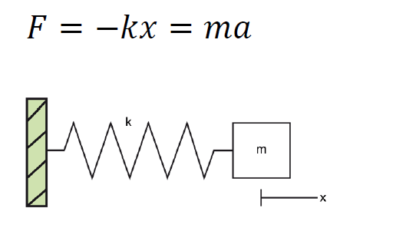
Figure 2.1:Working principle of a capacitive accelerometer

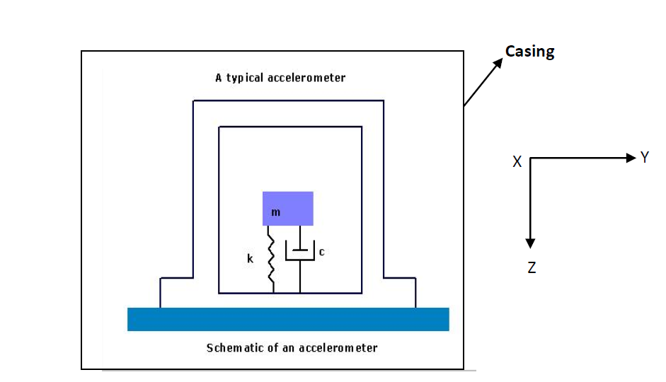
Figure 2.2: Accelerometer Theory & Design

As the picture2.2 above shows the schematic of an accelerometer, which be comprised of a mass (m), a spring (k) and a dash pot. When the object moves and has an accelerations, the mass moves to another position, the spring (k) will stretches and the dash pot will produce an relative damping coefficient(c) and the value (c) can be transfer to a digital signal or number which can be used directly.

The exact inner structure of an accelerometer is just like this, absolutely not, in our daily life, the most popular type of accelerometer is the Three-Axis Acceleration Sensor such as iPhone installing it. Just as its name implies, the three-axis accelerometer does not only test one direction’s acceleration, but three directions’ accelerations: X, Y and Z.

How an accelerometer works in mobile phone.
Here, we just use the three-axis accelerometer of an iPhone as an example to describe how an accelerometer works in an iPhone.
As we mentioned before, a three -axis accelerometer is used to test three different directions’ acceleration. There are two pictures below, which show three dimensional axis and the acceleration of every axis can be tested by the accelerometer installed in the phone.
And maybe some beginners will ask how to get the three axes data from an iPhone. Exactly, there are lots of app creating the function to catch the efficient data directly from the phone. Introducing one free iPhone APP named “Physics Toolbox Sensor Suite”, which can get not only the data of accelerometer from the iPhone to email to your email box, but also Gyroscope which will be discuss in next chapter and Magnetometer sensor. The data of accelerometer and gyroscope from an iPhone in this thesis is almost caught by this APP.

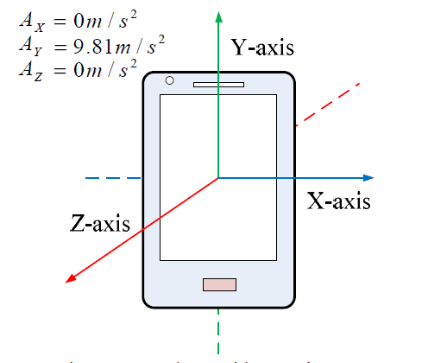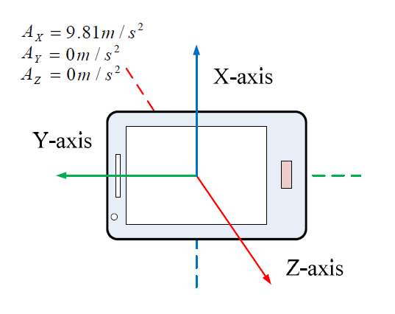
Figure 2.3:Using a Three-Axis Accelerometer and GPS Module in a Smart Phone to Measure Walking Steps and Distance

The principle of testing steps

How an accelerometer works in human body
When a pedestrian is walking on the road, the accelerometer will divide the motion acceleration by three directions, as we can see in Figure 2.4[]below: Vertical Direction, Forward Direction and Side Direction, which can be also called: X, Y and Z Axis.

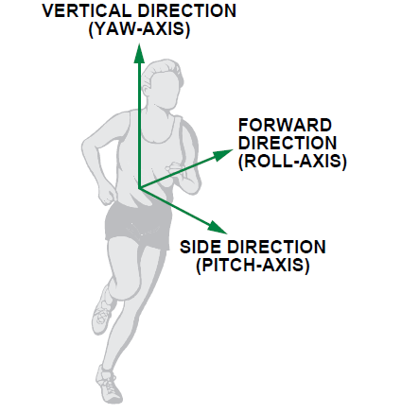
Figure 2.4:Full-Featured Pedometer Design Realized with 3-Axis Digital Accelerometer

The features of one steps
There is a swing phase showed in Figure 2.5 below ,which is a step period during people movement. Absolutely, there is a change process of speed of the leg movement during one step period, so we can catch the acceleration using the accelerometer.

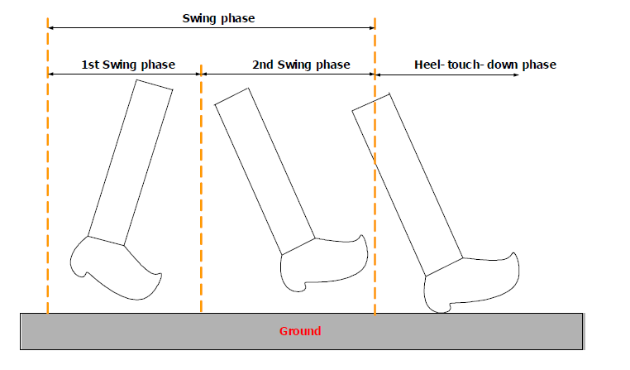

Figure 2.5:A Step, Stride and Heading Determination for the Pedestrian Navigation System

Figure 2.5below shows the typical three axes, x, y and z (matching vertical, forward and side acceleration) data of the accelerometer in my iPhone during walking, and what conclusion can be judged from this picture. So no matter how the pedometer wears the phone, there is at least one axis data have sharply periodic changes (this picture shows the Y axis changing sharply).

Figure 2.6:The three axes data of the accelerometer from iPhone
Normally, we can calculate a peak value and a bottom value during one step.
And we can use the sum formula to get a diagram below picture. As a valid step must have only one peak value and one bottom value.

Figure 2.7:The total accelerometer data after calculation

Key algorithms of recording steps

Peak Detection Algorithm
Four Basic Conditions can be used: (the frequency of the data caught in this chapter is in 50Hz)
1.Current point is going down.(The Red Point in the following diagram)
2. The previous point is going up.(The Black Point)
3. At least going up twice before coming to positive peak.(The pink lines).
4. The value of the positive peak should be bigger than 1.5g
And we can go on to understand this algorithm by referring to the following diagram.

Figure 2.8:The peak data of the Accelerometer

Transform Domain Algorithm
One condition can be used to exclude invalid data.
- The duration of two effective adjacent peaks must be longer than 0.2S and shorter than 2s. (Based on common sense)

Figure 2.9:The intervals among the peaks
So we can see the two red peak values are invalid using this algorithm.

Threshold Filtering Algorithm
Two Basic Conditions:
1. The current peak value minus the last valley value must be bigger than the threshold.
2. The Threshold is Dynamic and related with different walking patterns. (There is one red peak datum being filtered.)
The following diagram can be an example for this algorithm.

Figure 2.10:The threshold figure

Pattern Recognition Algorithm
One regulation is:
For examples:(the walking patterns)
- Walking, phone in pocket.
- Walking, phone in hands.
- Walking, phone beside ear.
- Running, phone in pocket.
In different patterns, you can see the distinction of the wave variation of accelerometer value from the picture on the right. The following diagram shows the difference between the pattern of walking with the phone in the pocket and the pattern of running with the phone in the pocket.

Figure 2.11:The different Pattern data

My pedometer program

The program operation
To run this program showed in follow picture, you can get the exact steps and the accuracy of steps calculation. How to use this program to calculate the steps, there are two procedures below should be done :
- Fill out the path of excel file of Accelerometer data and the test frequency before click Running.
- Fill in the exact count steps in the Exact Steps, and click Calculating.

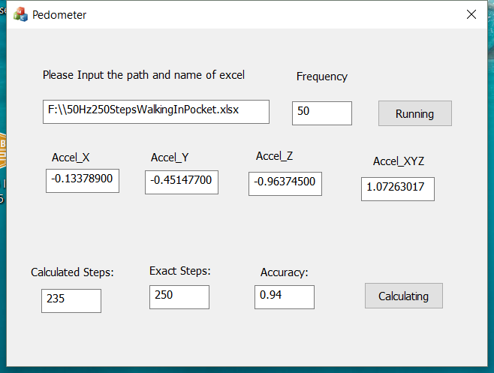
Figure 2.12:The program of calculating the steps

The accuracy of results
We can get the accuracy of this program and this algorithm showed in following form. Of course, there is not the most accurate program or algorithm, and the purpose is to show the method for calculating steps.

Action pattern | Placement of Iphone | Height | Weight | Age | ground condition | Frequncy | Number of step (exactly) | number of steps(by program) | Accuracy
Walking | in pocket of pants | 173cm | 60 Kilo | 28 | Flat | 25Hz | 150 | 250 | 0.6
Walking | in pocket of pants | 173cm | 60 Kilo | 28 | Flat | 50Hz | 235 | 250 | 0.94
walking | in hand(Natural Vertical) | 173cm | 60 Kilo | 28 | Flat | 50Hz | 243 | 258 | 0.94
Walking | Put the Phone Beside Ear (to answer the phone call) | 173cm | 60 Kilo | 28 | Flat | 50Hz | 192 | 250 | 0.77
Running | In pocket of Pants | 173cm | 60 Kilo | 28 | Flat | 50Hz | 258 | 250 | 0.97

Figure 2.13:The accurate data of the step algroithm

Gyroscope with balance racing game

The introduction of Gyroscope

What is a gyroscope
According to the English Oxford Dictionary, a Gyroscope is a "device consisting of a wheel or disc mounted so that it can spin rapidly about an axis which is itself free to alter in direction. The orientation of the axis is not affected by tilting of the mounting." [] Exactly, gyroscope is often used to detect the orientation that has similar function with compass. Nowadays the gyroscope becomes more and more popular and it has many applications such as used in inertial navigation systems and gyro compasses.
The most popular application is to be installed in the mobile phone. For example, it can work together with GPS in phones to help people navigate easier and more precise.

Working principle of a gyroscope
There are different kinds of gyroscopes, such as MEMS gyroscope、fibre optic gyroscope and the sensitive quantum gyroscope. Different types base on different principles of operation, and in this thesis, we just introduce the working principle of the most popular one used in iPhone.

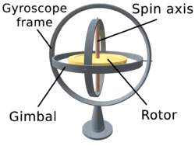
Figure 3.1:Wikipedia

As you can see the figure above above, there is a Rotor which can spin freely 360 degrees around a Spin axis in a Gyroscope frame and a Gimbal. This is a basic frame of the Gyroscope and the angular velocity in each direction can be detected by the free rotation of the rotor.

There is another picture below, figure 3.2, there is a clear space match between the gyroscope frame and coordinate graphs. Based on angular momentum the Rotor resists to changes in orientation, thereby allowing to measure the changes of the angles. The rotation or the angle changes in different directions or positions will affect a change of resistance of a gyroscope and in this way, we can calculate the angular velocity in those three-axes orientations, so this is a basic principle of how the gyroscope works.

Figure 3.2:Gyroscope Principles

The relationship between Gyroscope and Accelerometer
At first, it is clear that those two devices have different functions: Gyroscope senses the rotation, whereas the another is used to test the accelerometer. [ ]So the restriction of functions in two devices decides that they often have to work together.
There is an example to clarify the different functions of them. When an aircraft flies in the sky, the accelerometer can used to test the change of movement. So when an aircraft fly too fast in suddenly, the accelerometer can remind the pilot of the unsafe signal for the sudden change of the speed during flying forward. However, when the aircraft has some faults with an unsafe shake around itself, here the accelerometer cannot sense it, but the gyroscope can detect the any rotation of the aircraft to notice the pilot of the insecurity.
Through this example, we can further understand that they are totally different, but they can also make up for each other to achieve some functions.

The racing game with Gyroscope

How a gyroscope works in iPhone
Depending on the base of working principle of gyroscope, we continually discuss how a gyroscope works in a smart phone, here, using iPhone 6 as an example to describe. The three-axis MEMS gyroscope showed in picture below is often chosen by iPhone 6.

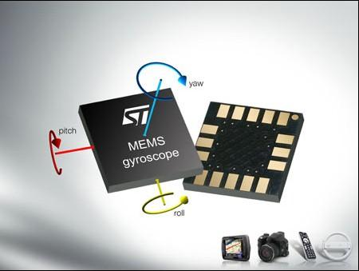
Figure 3.3: MEMS Gyroscope
Absolutely, a gyroscope must be used to test the angular velocity or the orientation, so here we only need to solve two questions:
- How to judge the current orientation of movement.
- How to get the correct angle of the phone in every axis.

Get the current orientation of movement of the phone.
- There is a figure 3.4 below showing the position of the gyroscope chip of the iPhone in the centre of the coordinate axis with three direction axes: roll, pitch and yaw (x, y and z), and they are almost 0 degrees.

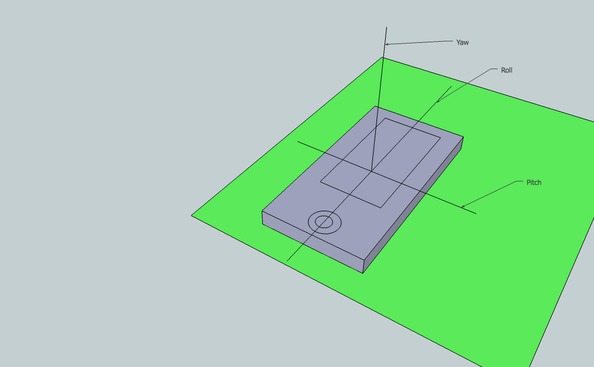
Figure 3.4: Gyroscope in iPhone
Here, when we try to rotate the phone up and down several times only around Pitch (x) axis, it will produce a change of the angular velocity showed in the figure below. It is clear that there is almost only one orientation data change happened on Pitch(x) axis. And what the information we can summarize is that any orientation the rotation happens it will cause the angular velocity on the corresponding axis.

Figure 3.5: The angular velocities of three axes data of Gyroscope
So we can judge the orientation of current movement through the angular velocity, if there is the angular velocity in one axis, it means the phone is rotating or moving in that direction and if the value is positive, that means the phone is moving forward, vice versa.

Calculating the current angle in Pitch axis
Before for calculating the current angle, we must be clear for two functions of the basic mathematics here. I believe everyone has studied them during high school or university Physics and Math lessons.
One of them is θ = dθ/dt [], θ means the angular velocity, dθ means radian and dt is the time period, what this function doing is to describe how to using the angular velocity to get the angle change during a period.
Since we can get the angle in a specific period using the function above, in the next step we need to think how to get the absolute angle in any time.
Therefor another function should be mentioned here:
Θ(t) = ∫(0,1t)Θ(t)*dt ≈ Σ(o,t)Θ(t)*Ts ^{[5]}

What function does is using the integral principle to integrate the angular velocity in all the period from time 0 ( t = 0) to get the absolute angle. However, this is just a theoretical formula and there are some errors caused by two reasons. First one is because the sampling frequency is possible slower than the data changes and another cause is drift which causes the sensor reading not returning to 0 at the rest position, so to avoid those errors it is better to choose the high sampling frequency (100 Hz in Gyroscope used in this thesis). The next part, there is an example for explaining how to use those equations to calculate an exact angle.

How a gyroscope works for the racing game

The principle of the racing game


Figure 3.6: Racing Game in iPhone

Anybody may play the racing game in mobile phones or Pads and it is really easy to get how to play it after trying several times. What you should do for operating this game is to control the horizontal balance offset for controlling the direction of the running of the car, in another word, just controlling the angle of the horizontal offset (or pitch axis in the picture below) can control the tilting direction of the car running. In a word, using the gyroscope to get the exact angle in Pitch (x) axis is the key point of this game.

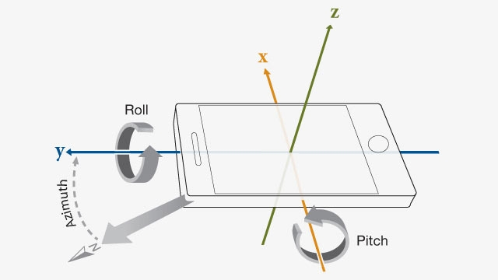
Figure 3.7: Gyro in the iPhone

Getting the exact angle offset in horizontal level (Pitch axis)
Here using iPhone 6 as an example, 100 Hz sampling rate. This is ideal option of the frequency, but in different situations should be set in different frequencies for reducing the error rate.
There are gyro data caught from iPhone in the form below during playing a racing game. It simulates the action of playing race game through rotating the iPhone 6 around Pitch axis and we can ignore Roll and Yaw data, since we do not need to use them in this condition.

Figure 3.8:Racing Gyro data of three axes
Here，from the picture above, we can use the integral principle mentioned above to collect the corresponding angle value below. What we can see from the form below is the phone are rotated about 50 degrees around Pitch axis. Obviously there is a certain error because of the disturbance, and another way for calculating a more accurate angle will be discussed in next chapter for enhancing the accurate rate.

Figure 3.9:The pitch angle offset from the racing game

A Glow Stick with Accelerometer and Gyroscope
From those three chapters above, we can know how to use Accelerometer and Gyroscopes to identify or detect some kinds of actions or postures, but it is possible to use it in a new action recognition and how a glow stick can show different colour lights in different actions, those will be discuss in this chapter.

Appearance and function description

A normal glow stick
How a normal glow stick works, everyone may have some experience for that. There is a picture below, when you turn on the switch on the handle, a glow stick will be lit in a specific colour.
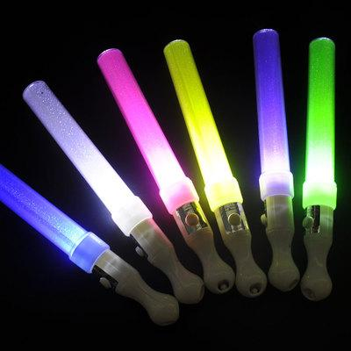
Figure 4.1: A kind of glow sticks
There is no doubt that it is very gorgeous in a concert when the countless light sticks come on.

Figure 4.2: A Vocal Concert

A multifunctional glow stick
What kinds of new functions can be created for a glow stick, absolutely it is related with posture or action recognition algorithm.
You can imagine if the light sticks shaken in different directions will show different colors of light, it will be a very interesting idea. For example, when you shake the light sticks in perpendicular to the body, the glow stick will display the blue colour, and in the parallel plane to body, the glow stick will show the yellow colour, or in a round way above you body, the glow stick will show the red colour.
So the automatic action or posture recognition is the key point for this function, and it is what have been mentioned above.
On the other hand, not only the colors of light can be controlled by different postures, but also the accelerometer and gyroscope can be used to adjust the brightness of lights.

Figure 4.3: Audiences shake glow sticks

How and why need Accelerometer and gyroscope
There are two functions mentioned above, which should be made sure in multifunctional glow sticks, and those functions are both relative with action recognition algorithm and acceleration.

The new action recognition
First of all, function 1, shaking in different directions the glow sticks will display different colors of light. There are three postures or actions those should be identified by the sticks, here the accelerometer and gyroscope can be used to analyse or recognize those postures.
Action 1: shaking the sticks in perpendicular to the body, the stick should display blue color.
Action 2: shaking in the parallel plane to body, the glow stick should show the yellow colour.
Action 3: rotating above you body, the glow stick should show the red colour.

Accelerometer and Gyroscope in the iPhone 6
How the accelerometer and Gyroscope work in iPhone 6, which have mentioned in last two chapters.In the last charter, we already got that Gyroscope senses the rotation, whereas the another is used to test the accelerometer.And there are some pictures below showing the devices going to test what, Gyro tests the spinning angle and Accelerometer tests the angles in three directions relative with the gravity . Here, we use the iPhone to simulate a multifunctional glow stick and setting the screen of the iPhone 6 is parallel with my body and faces forward. There are two pictures below showing the x,y and z axes of Accelerometer and Pitch, roll and yaw of Gyroscope in iPhone 6.

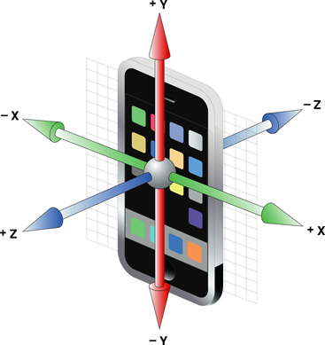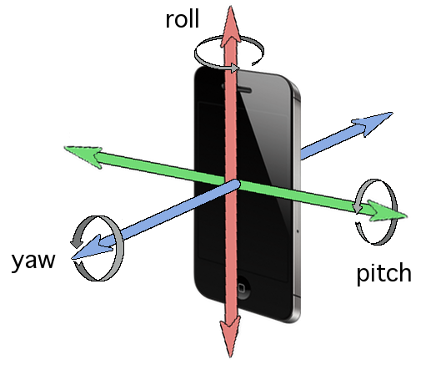

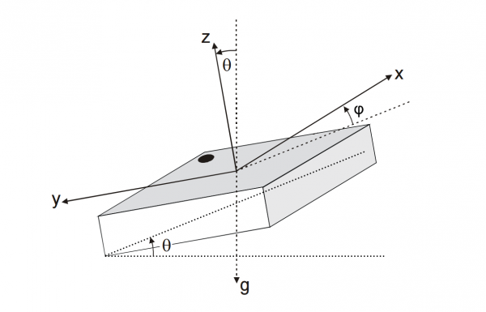
Figure 4.4:Scanning rooms with an iPhone

Using Accelerometer and Gyroscope for the angle restrictions.
For those three action recognition, exactly maybe just only using the accelerometer can calculate an enough precise angles in three direction relative with the gravity. However, it is not enough for totally identifying those three actions, since sometimes the glow stick may rotate by itself, this is not tested by an accelerometer. In a word, the key point is to make sure the restrictions or standards for controlling a exact and precise range of the angle changes in different directions. So first of all, we need to know how those two devices calculate the useful angles.
The last chapter mentions only using gyroscope to calculate the angle of the rotation around pitch axis in Racing Game. However,the angle calculated in this way is inaccurate (the reasons have been mentioned in previous chapter), there is another way to get an accurate angle , which needs to use Accelerometer and Gyroscope both.

Low-pass filtering for Gyro calculating a long term spinning angle.
What is low-pass filtering algorithm it can be searched in lots of websites and it is easy to understand. Since the two device reflect oppositely in long term and short term running, for example, when Gyro runs for a long time, the drift will increase and at the same time the accuracy of angle calculating will decrease. Here, we can use low-pass filtering algorithm to marge the acceleration value with gyroscope value, which can reduce the drifting error. There is a formula for merging the two kinds of values and with a diagram showing the function of the Merging Algorithm.
Mgyro = K1 * Cgyro + K2 * Caccel;
Rgyro: the angular velocity after merging algorithm.
Cgyro:the real-time angular velocity.
Caccel: the real-time acceleration.
K1: here is 0.95.
K2: here is 0.05.
The parameter K1,K2 is parameters for reducing the fluctuations in the short term.

Figure 4.5:Spinning Angle after High-pass algorithm

Calculating a slant angle the by Accelerometer
At first, let us try to only use the Accelerometer to calculate the angle of action 1: shaking the sticks in perpendicular to the body. We can imagine that when the glow stick is shaken in perpendicular direction with the body, nearly only the acceleration of Z axis acceleration will change during the shaking period.

How can we calculate the angle value by only accelerometer?
We should use the gravity during this process. First of all, let us see a picture below, imagine that is a phone put on the horizontal desk and the g means gravitational acceleration which is g=9.80665 m/s^2, which should not be taken much time to explain more.

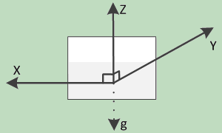
Figure 4.6: The direction of the gravitational acceleration of an object
When the position changes like the picture below, and what information we can get is that the acceleration of X , Y and Z are Ax, Ay and Az respectively, and the value of radian: α1 、β1 、γ1 are the angles between X, Y and Z with horizontal line respectively and absolutely α 、β 、γ are the angles between X,Y and Z with g line: α = 90°- α1， β = 90°- β1 ， γ = 90°- γ1。We can get: Ax = gcosα， Ay = gcosβ ， Az = gcosγ, and changing a formula to Ax = gcosα = gcos( 90°- α1) =gsinα1 and also Ay = gsinβ1 ， Az = gsin γ1.
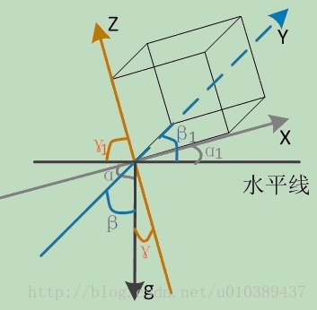
Following the picture below and using Pythagorean proposition, we can get g*g = Ax*Ax + gcosα1*gcosα1, so other equations can be got using Trigonometric function theorem at same time: gcosα1 = sqrt(g*g - Ax*Ax) ，gcosβ1 =sqrt(g*g - Ay*Ay )，gcosγ1 =sqrt(g*g - Az*Az )). There is another equation got by principle of equilibrium: Ax*Ax + Ay*Ay + Az*Az = g*g.

Here, using the equations we already got: sinα1 = Ax/g， cosα1 = sqrt(g*g - Ax*Ax) / g. And another changing equation is tanα1 = Ax / sqrt(Ay*Ay + Az*Az) . In the same way, we can get tanβ1 = Ay / sqrt(Ax*Ax+Az*Az) ，tanγ1 = Az / sqrt(Ax*Ax +Ay*Ay)。
The Radian respectively:
α1 = arctan(Ax / sqrt(Ay*Ay + Az*Az))
β1= arctan(Ay / sqrt(Ax*Ax+Az*Az))
γ1= arctan(Az / sqrt(Ax*Ax +Ay*Ay))
And also using Radian = θπR/180 formula to get the real angle value:
θx = α1*180/π = [arctan(Ax / sqrt(Ay*Ay + Az*Az))] *180/π
θy =β1*180/π = [arctan(Ay / sqrt(Ax*Ax+Az*Az))]*180/π
θz =γ1*180/π = [arctan( Az / sqrt(Ax*Ax +Ay*Ay))]*180/π
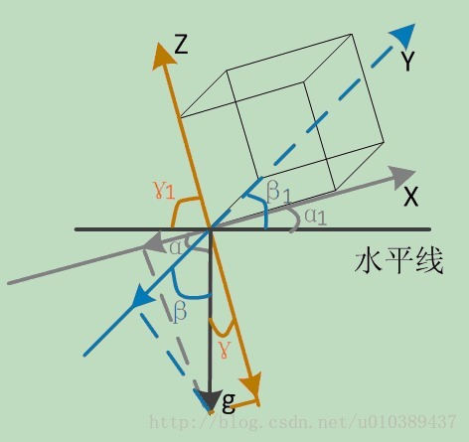

Using the angle calculation formula, we can get a diagram below shows an iPhone is put up from a desk. The angle changes below in three directions, X, Y and Z, Y axis changes from -90° to 0° and Z axis changes oppositely from 0° to 90°，and absolutely the X almost does not change since the X axis is alway parallel with the desk level.
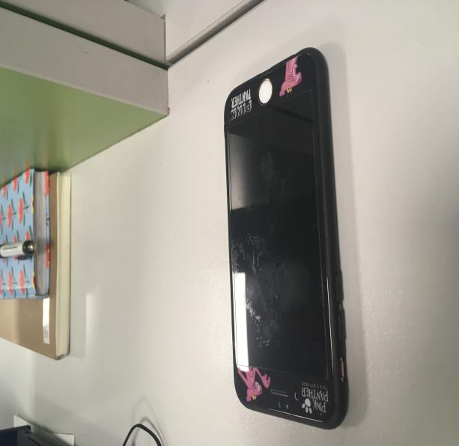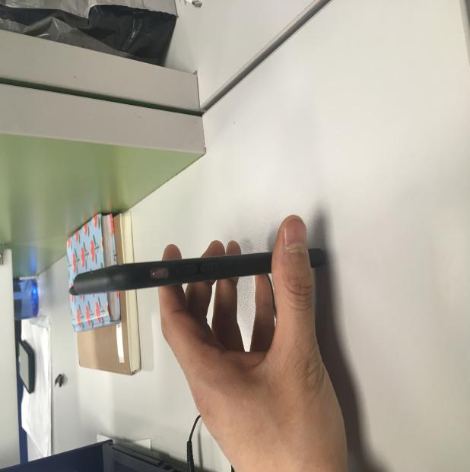
Figure 4.7:Put the phone up

Figure 4.8:Gyro data chang

Using those two kinds of angle restriction together to control or identify those three actions
The standards for the definition of restrictions for the spinning angle and the deflection angle are to control those two kinds of angles together to control the glow stick lighting a specified color in a fixing area or a fixing action. So here for making the restriction of angle range of the action we should catch the real data and think a abstract space diagram to make sure a useful standards or restrictions.
There are two ranges of self-spinning angle and deflection angle from gyro and accelerometer, which be used together to identify actions. For example, the action1, when you rotate the glow sticks over the range, it will judge you in a wrong action or not action1, this can be tested by gyro. And also, when you shake the glow stick in a very small angle range relative with the gravity, it can be identified since the angle change are not satisfied with standards which can be tested by Accelerometer.
There are some angle range restriction below for three different actions.
Action1: shaking the sticks in perpendicular to the body, the stick should display blue color.
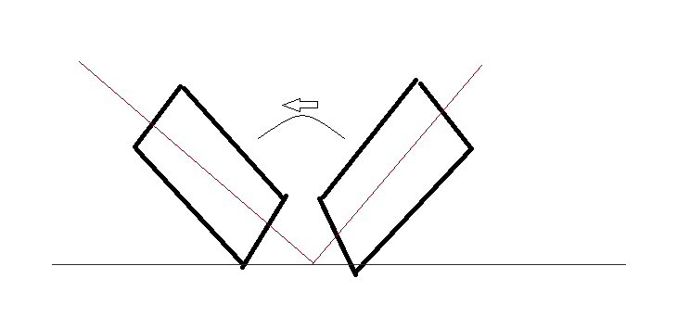
Figure 4.9: Shank the Phone in action1

Figure 4.10:Spinning angle changes in action 1

Table 4.1:Spinning angle restrictions in action 1
Gyro valid rang | One side | Maximum
X-axis | -30° | 30°
Y-aixs | -10° | 10°
Z-aixs | -10° | 10°

Figure 4.11: Angles with the gravity changes in action1
Predicting the angle range by Accelerometer data, keeping in this range for a long time, when getting the large angle to show a stronger light.

Table 4.2: Angles with the gravity restrictions in action 1
Accel | One side Range | Another
X-axis | 0°to 25° | 0°to 25°
Y-aixs | -25°to -55° | 25°to 55°
Z-aixs | -30°to -70° | 30° to 70°

Action 2: shaking in the parallel plane to body, the glow stick should show the yellow colour.

Figure 4.12:Spinning angle changes in action 2
Table 4.3:Spinning angle restrictions in action 2
Gyro valid rang | Minimum | Maximum
X-axis | -10° | 10°
Y-aixs | -10° | 10°
Z-aixs | -30° | 30°

Figure 4.13: Angles with the gravity changes in action 2
Table 4.4:Angles with the gravity restrictions in action 2
Accel | One side Range | Other side
X-axis | -40°to -70° | 40°to 70°
Y-aixs | -20°to -55° | 25°to 55°
Z-aixs | In -30°- 0 | In 0° to 30°

Action 3: rotating above you body, the glow stick should show the red colour.

Figure 4.14: Spinning angle changes in action 3
Table 4.5: Spinning angle restrictions in action 3
Gyro valid rang | Minimum | Maximum
X-axis | -15° | 15°
Y-aixs | -15° | 15°
Z-aixs | -20° | 20°

Figure 4.15: Angles with the gravity changes in action 3

Table 4.6:Angles with the gravity restrictions in action 3
Accel | One side Range | Other side
X-axis | -40°to -80° | 40°to 80°
Y-aixs | -10°to -55° | 10°to 55°
Z-aixs | -70°- -30° | 30° to 70°

References

[] Engineering-sciences.uniroma2.it. (2018). Working principle of a capacitive accelerometer. [online] Available at: http://engineering-sciences.uniroma2.it/MENU/DOC/TESI/2013/2013_tesi%20NISTICO%20Andrea.pdf [Accessed 21 Mar. 2018].
[] Analog.com. (2018). Full-Featured Pedometer Design Realized with 3-Axis Digital Accelerometer | Analog Devices. [online] Available at: http://www.analog.com/en/analog-dialogue/articles/pedometer-design-3-axis-digital-acceler.html [Accessed 22 Mar. 2018].
[] McFadden, C., Shop, I., Vyas, K., Miley, J., Engineering, I. and Barnett, T. (2018). What are Gyroscopes and Why are They Important?. [online] Interestingengineering.com. Available at: https://interestingengineering.com/what-are-gyroscopes-and-why-are-they-important [Accessed 21 Mar. 2018].
[] Uk.mathworks.com. (2018). Android Sensor Support from MATLAB. [online] Available at: https://uk.mathworks.com/hardware-support/android-sensor.html?s_tid=test [Accessed 20 Mar. 2018].
[] Pieter-jan.com. (2018). Getting the angular position from gyroscope data | Pieter-Jan.com. [online] Available at: http://www.pieter-jan.com/node/7 [Accessed 21 Mar. 2018].

